How to use Matlab on the Virtual Labs
The following link provides information on how to connect to the virtual labs for Windows or Mac users. http://www.ou.edu/content/coe/audience/current/eng_technology/computerlabs/virtuallab.html
The rest of the information in this document goes through a step by step process for windows users. However, much of the information will also apply to Mac users. If you are a Mac user and can’t get into the virtual labs after reading the information in the link above then contact IT at 325-HELP.
Matlab License Change
In 2010 OU changed its license agreement with Mathworks that requires undergraduates to use Matlab on the virtual lab server instead of installing it on their own computer. This virtual lab also has many other software packages you might be interested in using at some point, such as: LabVIEW, AutoCad, OrCad, etc. As of August 2011, the current version of Matlab on the virtual lab server is R2009B, but is updated as new releases are available. For most of your classes in ECE any version of Matlab will work as long as it has the following toolboxes: Control Systems, Signal Processing, and Symbolic. To see if these toolboxes are installed, open Matlab and click Help, then click function browser, and see if the toolboxes are listed. If you purchase the student version of Matlab so that you don’t have to log into the OU network then make sure you are getting these toolboxes with your purchase.
Using Matlab off campus:
If you are off campus you will have to VPN into OU before you can access the virtual labs. The VPN client can be downloaded for free from itstore.ou.edu. Windows users can also download it directly from this location: http://support.microsoft.com/kb/925876
After installing the VPN virtual client click on its executable and the following window will appear:
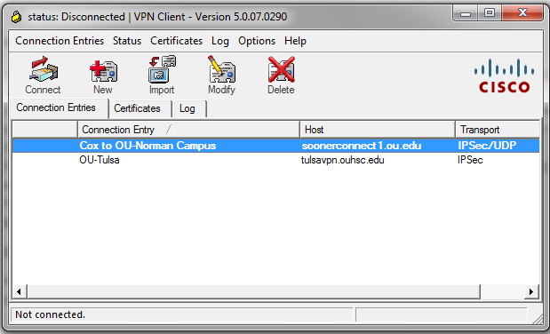
Click on connect to OU-Norman Campus and enter your 4x4 and password and you are in. Your “4x4” is the same thing you use to access OU email. You will stay connected until you disconnect on VPN. Remember you only need to use VPN if you are OFF CAMPUS. If you try to use VPN when you are ON CAMPUS you will get the following message:
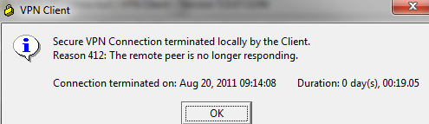
Connecting to the Virtual Labs using Windows:
1. Open Remote Desktop. For Windows 7 you can type "remote desktop" in the search menu.
2. Click on the remote desktop icon.
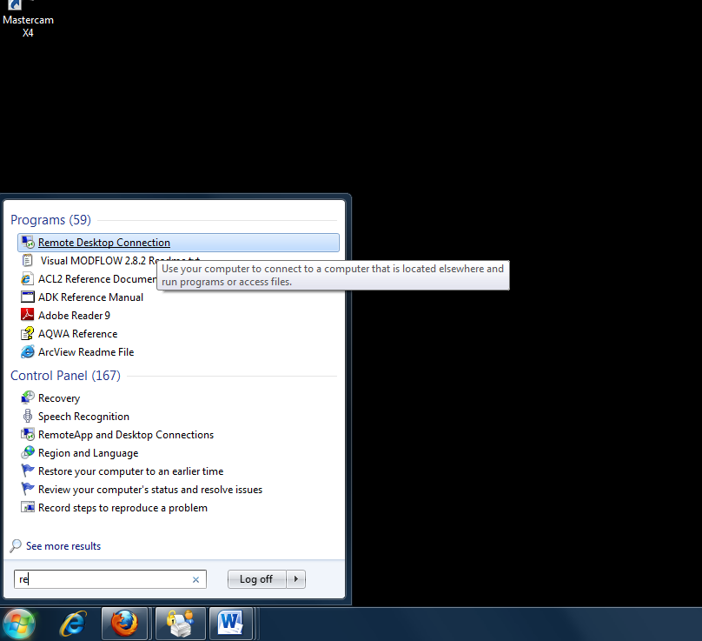

3. Type in "it-coets2.itsc.ou.edu"
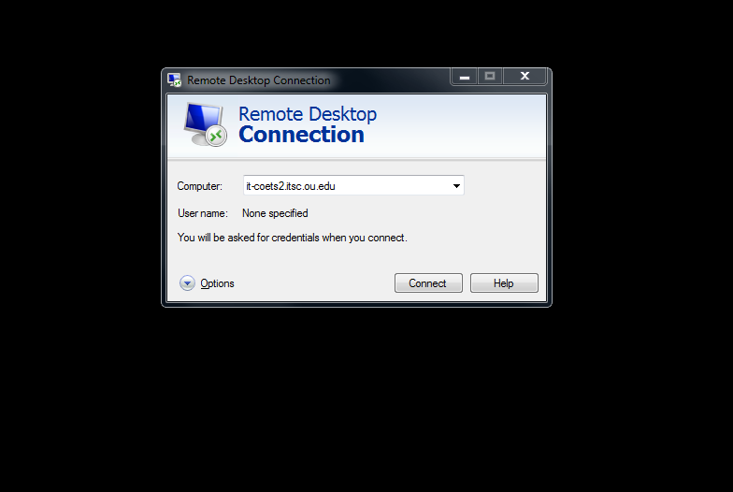
- Type “sooner\4x4” in the user name.
- Once you are logged in you can go to the start menu and open Matlab. You will need to use your H:\Drive for any files you are saving or copying. Every OU student has an H:\Drive that they can use to store data. Your H:\Drive will be automatically mapped when you log into the virtual labs. Some students that don’t use their H-Drive frequently like to email themselves their files before logging out of the virtual labs. The network location of your H-Drive is at \\washington.ou.edu
CAUTION:
If you close your remote desktop connection without logging out of that computer then you will not be able to connect to virtual labs again for about 30 minutes. So try to remember to log off before you close the remote desktop connection. One thing many people don’t realize is that you can minimize or resize your remote desktop connection window and work on your own computer without logging out.
ECE MATLAB Trainer:
Learning Matlab will be an intimidating adventure for some of you. The School of ECE is trying to help with this learning curve by employing a highly skilled Matlab Trainer each semester to help you get up to speed. I encourage you to take advantage of this service. For Fall 2010 the Matlab trainer information is as follows:
Asish Madhavaram
Office Hours: Monday: 4PM - 5PM, Tuesday: 3:30PM - 4:30PM
Room Number: DEH325
e-mail: Asish.Madhavaram-1@ou.edu

